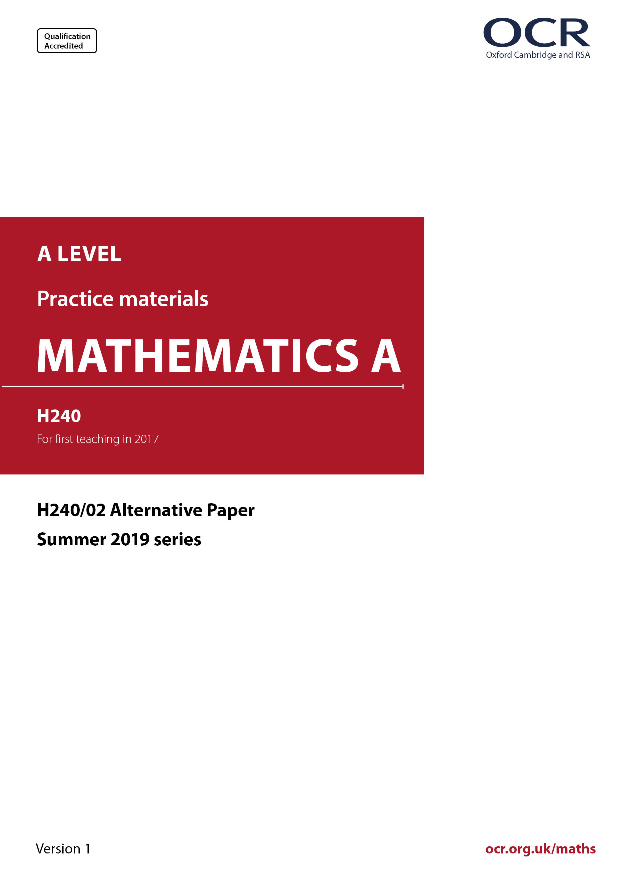
_{PP}
ocr.org.uk/maths

Introduction
OCR’s Alternative Papers for A Level Mathematics A are each created by taking one of our past papers and amending the numbers/graphs/diagrams/tables/etc. in its questions.
This Alternative Paper is an amended version of one of the June 2019 series papers. The wording and topics assessed are essentially the same, but the responses students need to make will be different. Using both this paper and the corresponding June 2019 exam paper with your students at different points in the year will allow you to monitor how their learning has progressed in the time between the two papers.
June 2019 was the first full assessment of the reformed linear A level Mathematics and Further Mathematics qualifications.
The June 2018 series was unusual, sat by a small cohort after one year of teaching of the new specification and with the majority of candidates intending to study Further Maths in the second year.
External examinations in 2020 and 2021 were not held in the summer. Autumn series were held in these two years, with small cohorts.



A Level Mathematics A
H240/02 Pure Mathematics and Statistics
Alternative Paper (June 2019)

Time allowed: 2 hours

You must have:
- Printed Answer Booklet

You may use:
- a scientific or graphical calculator

INSTRUCTIONS
- Use black ink. You can use an HB pencil, but only for graphs and diagrams.
- The Question Paper will be found inside the Printed Answer Booklet.
- Use black ink. HB pencil may be used for graphs and diagrams only.
- Answer all the questions.
- Write your answer to each question in the space provided in the Printed Answer Booklet. If additional space is required, use the lined page(s) at the end of this booklet. The question number(s) must be clearly shown.
- You are permitted to use a scientific or graphical calculator in this paper.
- Give non-exact numerical answers correct to 3 significant figures unless a different degree of accuracy is specified in the question.
- The acceleration due to gravity is denoted by g m s^{–2}. Unless otherwise instructed, when a numerical value is needed, use g = 9.8.

INFORMATION
- The total mark for this paper is 100.
- The marks for each question are shown in brackets [ ].
- You are reminded of the need for clear presentation in your answers.
- The Printed Answer Booklet consists of 16 pages. The Question Paper consists of 14 pages.

Formulae
A Level Mathematics A (H240)

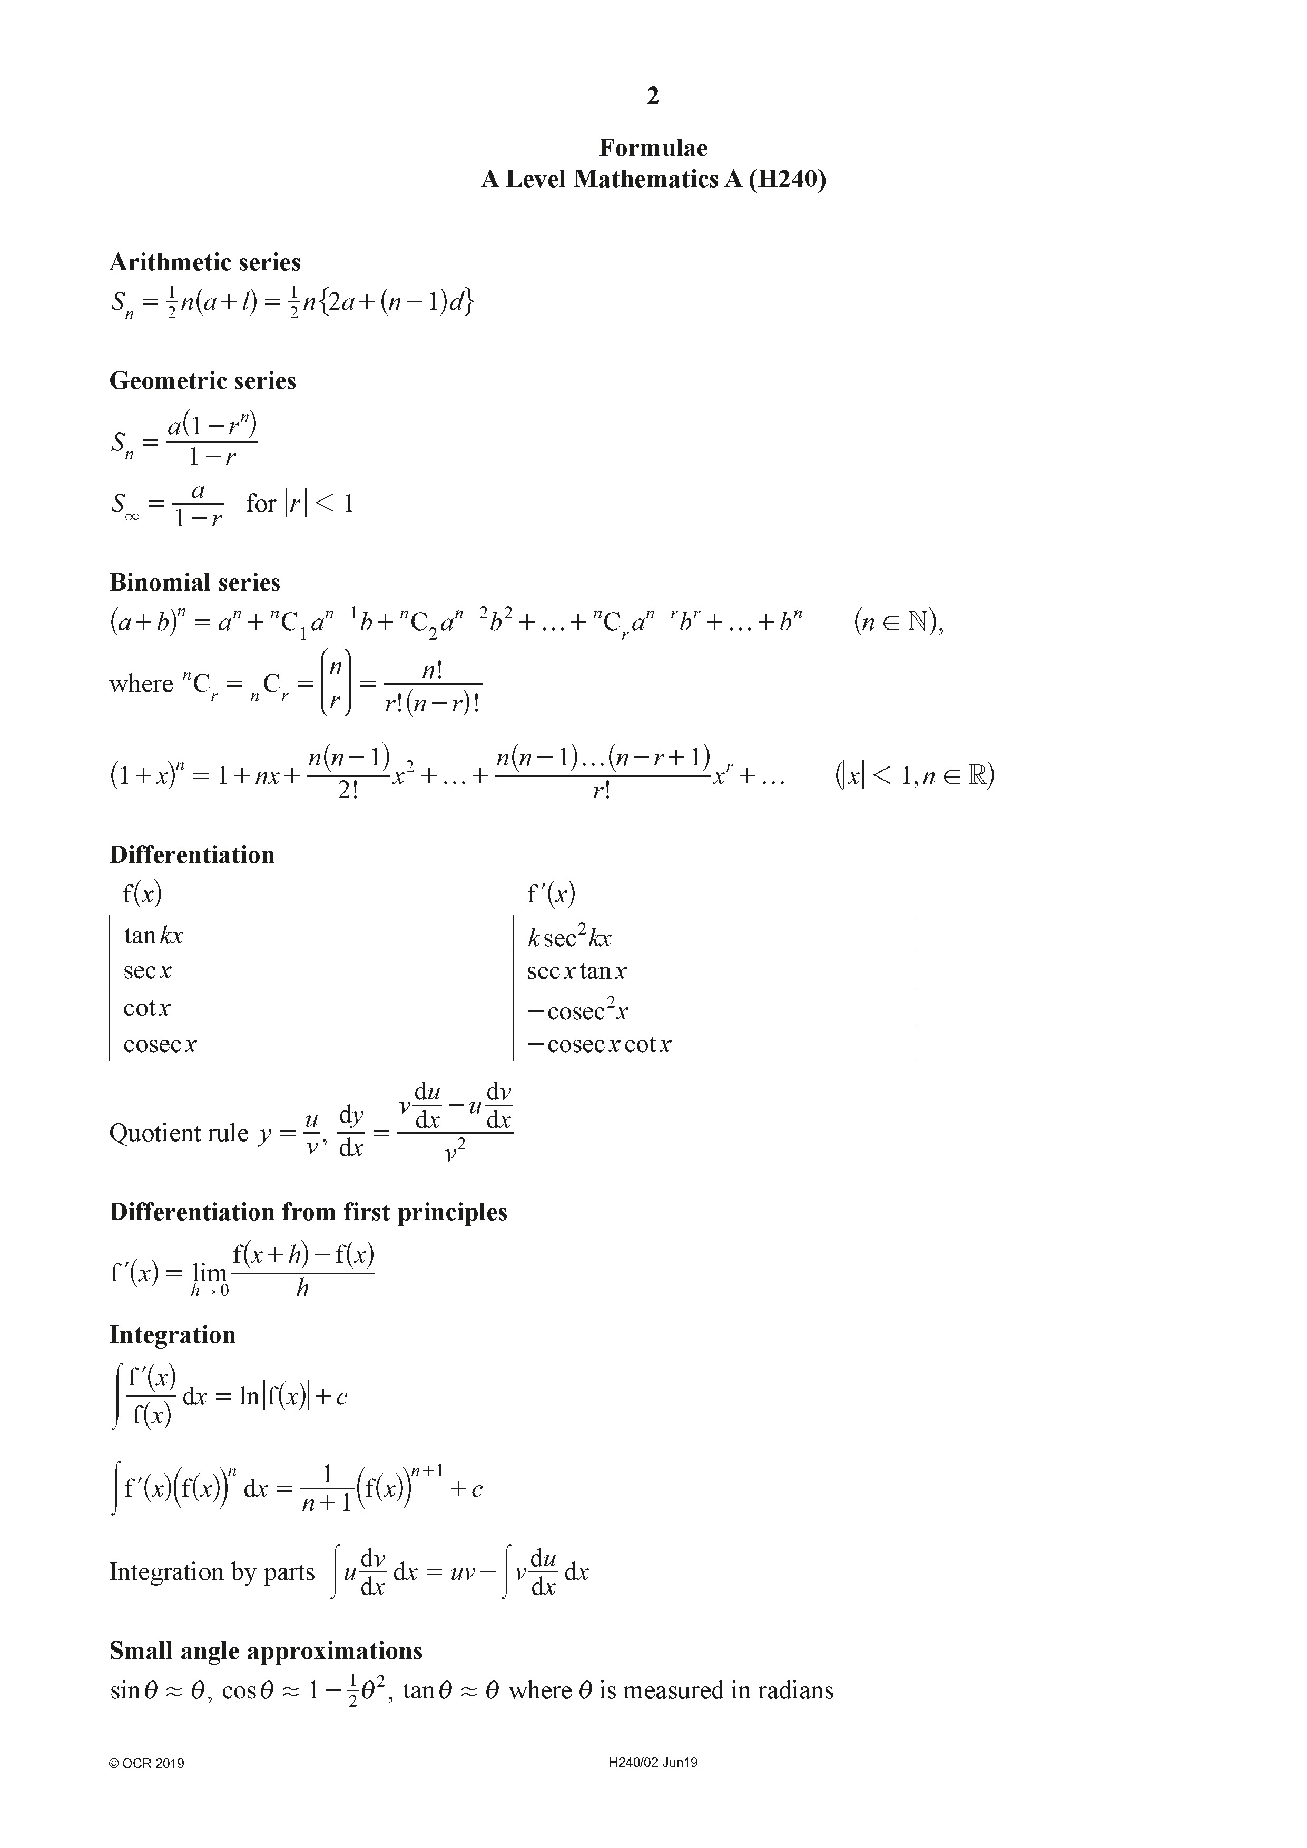

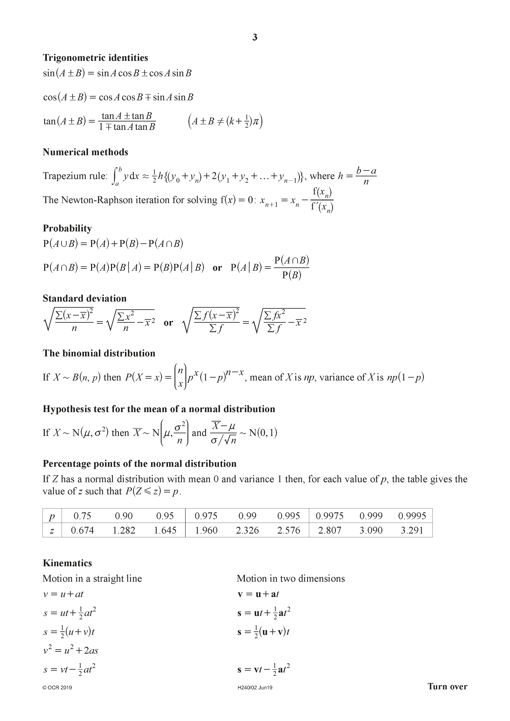

Section A: Pure Mathematics
Answer all the questions.

1 (a) Differentiate the following.

(i) [3]

(ii) . [2]

(b) Use the substitution to integrate . [4]

(c) Integrate . [2]

2 (a) Find the coefficient of in the expansion of . [1]

(b) (i) Expand up to and including the term in . [3]

(ii) State the range of values of for which your expansion is valid. [1]

In a science project, the calculation for is needed to an accuracy of
3 significant figures.

(iii) Showing your working, determine whether the expansion in (b)(i) is accurate to 3 significant figures in comparison to the value obtained by calculator. [3]

3 A curve is defined by the parametric equations x = 8 cos 2θ, y = 5 sin 4θ.

(a) Show that the cartesian equation of the curve can be written as ,
where a is a rational number and b is an integer. [3]

(b) (i) Show that , where p and q are rational
numbers to be determined. [4]

(ii) Hence show that the gradient of the normal to the curve at the point where θ = $\frac{π}{6}$ is given by , where k is a rational number to be determined. [2]

4 A scientist is studying an endangered species of animal that has been re-introduced onto an island. The scientist proposes two models for estimating the population P after t years. The diagrams show these models as they apply to the first 20 years.

 | Model A | Model B
 | 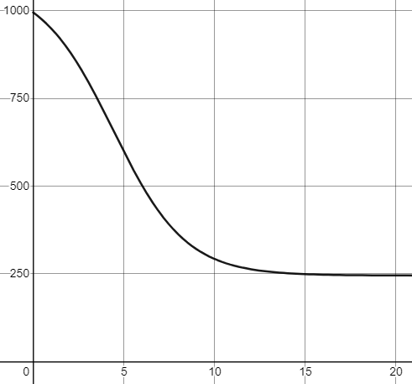 | 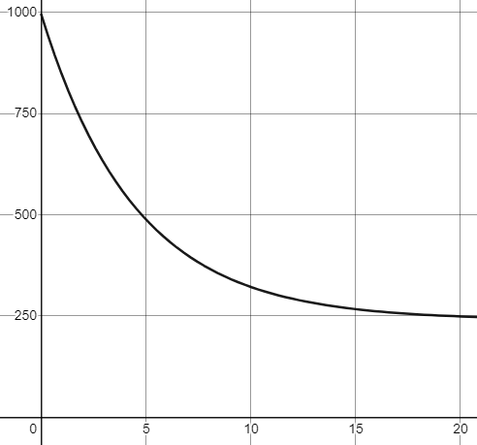

(a) Without calculation, describe briefly how the rate of decay of P will vary for the first 20 years, according to each of these two models. [1]

The equation of the curve for model A is .
The equation of the curve for model B is .

(b) (i) Describe the behaviour of that is predicted for t > 20 using model A. [1]

(ii) Describe the behaviour of that is predicted for t > 20 using model B. [1]

There is only a limited amount of food available on the island. The scientist assumes that the size of the population depends on the amount of food available and on no other external factors.

(c) State what is suggested about amount of food available by both models. [1]

(d) What is the size of the initial population introduced to the island? [1]

5
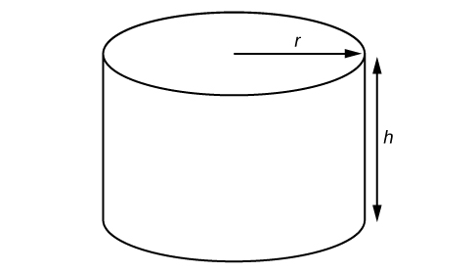

The diagram above shows a cylinder with base radius r, height h.

The cylinder has a base and no lid. The base radius is r cm and the volume is V cm³.

The area of the material to be used for the cylindrical container is 60π cm².

(a) Show that . [4]

(b) In this question you must show detailed reasoning.

It is given that V has a maximum value for a certain value of r.

Find the maximum value of V, giving your answer correct to 3 significant figures. [5]

6 Ben states the following:

“If a is an odd positive integer greater than 1 is divisible by 8”.

Prove that the statement is true when a = 5. [4]

7 In this question you must show detailed reasoning.

The letters a, b, c, d and e are defined by

.

Find the values of a, b, c, d and e. [5]

Section B: Statistics
Answer all the questions.

8 The stem-and-leaf diagram shows the percentage of people in employment that cycle to work in each of the 33 London boroughs in 2011.

0 | 8 | 9
1 | 1 | 2 | 2 | 4 | 4 | 4 | 4 | 5 | 6
2 | 1 | 3 | 5 | 7 | 9
3 | 2 | 3 | 8
4 | 0 | 5 | 6 | 8
5 | 1 | 9
6 | 2 | 4
7 | 1 | 1 | 2 | 8
8
9 | 1
10
11
12
13 | 8

Key
5 | 1 means 5.1%

(a) Find the median and inter-quartile range of the data. [3]

(b) Calculate the mean and standard deviation of the data. [2]

(c) (i) Show that there is an outlier in this data set. [1]

(ii) Use your knowledge of the large data set to explain why this data cannot be used as a measure of the percentage, in each London borough, of road users who are cyclists. [1]

9 (a) The times, in minutes, of students to run a 10K race have the distribution N(60, 57).

(i) A runner whose time is between 50 and 70 minutes is classified as a leisure runner. Find the probability that a student runner chosen at random will be classed as a leisure runner. [1]

(ii) The fastest 5% of runners were considered for the university athletics team.

Find the slowest time the taken by a runner who was considered for the team. [1]

(iii) Blood tests are taken from a randomly selected group of 10 runners.

Find the probability that the group of runners chosen at random has a total time of
less than 550 minutes. [4]

(b) The times at a specific 10K race for elite runners have the distribution N(µ, 1.824²). It is given that 19 out of 20 elite runners had a time greater than 29 mins.

Determine the value of µ. [5]

10 For a particular species of ant, the length, in millimetres, of one of the antennae is denoted by the random variable X, where X has the distribution N(μ, 0.00005625).

In the UK as a whole the value of μ is known to be 0.0752.

In an unusual habitat a colony of ants of this species is studied. The mean length of antennae for 50 randomly chosen ants in this habitat is found to be 0.0772.

Test, at the 5% significance level, whether the mean length of antennae of ants in this habitat is different from the mean length of antennae of ants in the UK as a whole. [7]

11 A trainer was asked to give a lecture on population profiles across 12 Unitary Authorities (UAs) in the South East of the UK. Using data from the 2011 census, she obtained the following data to create a scatter diagram.

Unitary Authorities in South East England | Age 0 to 4 | Age 20 to 29
Bracknell Forest | 8 027 | 14 070
Brighton and Hove | 15 015 | 51 127
Isle of Wight | 6 412 | 13 498
Medway | 17 224 | 36 622
Milton Keynes | 19 908 | 33 652
Portsmouth | 13 548 | 39 752
Reading | 11 937 | 29 687
Slough | 12 777 | 22 925
Southampton | 15 407 | 51 169
West Berkshire | 10 065 | 15 847
Windsor and Maidenhead | 9 365 | 15 952
Wokingham | 10 031 | 15 499

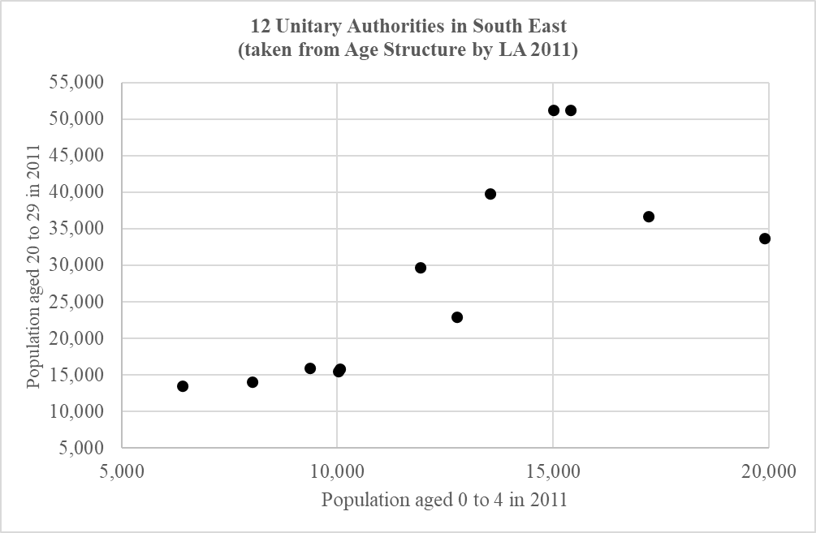

The population aged 0 to 4 and the population aged 20 to 29 are denoted by P_{A} and P_{B} respectively. The following conclusions were made by three students attending the lecture.

(a) Student X uses the data to find a Pearson’s product-moment correlation coefficient
(PMCC), r, between P_{A} and P_{B}. He states that r = –0.759.

Use the scatter diagram to explain why this value is likely to be incorrect. [1]

(b) Student Y thinks that one data point is an anomaly and discards the data for that point. She carries out a hypothesis test using the following hypotheses.

H₀: There is no positive correlation between the sizes of P_{A} and P_{B}.
H₁: There is positive correlation between the sizes of P_{A} and P_{B}.

She found that the value of Pearson’s product-moment correlation coefficient for the 11 Unitary Authorities is 0.860, correct to 3 significant figures. She concluded that this proved, at the 0.05% level of significance, that there was positive correlation.

(i) Use the table on the next page to determine the validity of this conclusion. [3]

The value of the PMCC for all 12 Unitary Authorities, including the discarded one, is 0.759.

(ii) If the data for the discarded Unitary Authority was included, would the decision about there being positive correlation change? [2]

(iii) Use the information from the table and the scatter diagram to identify the discarded Unitary Authority, giving a reason for your answer. [1]

(c) Student Z states that the table and scatter diagram clearly identify the Unitary Authorities with large student populations. Using your knowledge of the Large Data Set, suggest one reason why this statement might be true. [1]

Critical values of Pearson’s product-moment correlation coefficient

1-tail test | 5% | 2.5% | 1% | 0.5% | 0.05%
2-tail test | 10% | 5% | 2% | 1% | 0.1%
n
1 | - | - | - | - | -
2 | - | - | - | - | -
3 | 0.9877 | 0.9969 | 0.9995 | 0.9999 | 0.9999
4 | 0.9000 | 0.9500 | 0.9800 | 0.9900 | 0.9990
5 | 0.8054 | 0.8783 | 0.9343 | 0.9587 | 0.9911
6 | 0.7293 | 0.8114 | 0.8822 | 0.9172 | 0.9741
7 | 0.6694 | 0.7545 | 0.8329 | 0.8745 | 0.9509
8 | 0.6215 | 0.7067 | 0.7887 | 0.8343 | 0.9249
9 | 0.5822 | 0.6664 | 0.7498 | 0.7977 | 0.8983
10 | 0.5494 | 0.6319 | 0.7155 | 0.7646 | 0.8721
11 | 0.5214 | 0.6021 | 0.6851 | 0.7348 | 0.8470
12 | 0.4973 | 0.5760 | 0.6581 | 0.7079 | 0.8233
13 | 0.4762 | 0.5529 | 0.6339 | 0.6835 | 0.8010
14 | 0.4575 | 0.5324 | 0.6120 | 0.6614 | 0.7800
15 | 0.4409 | 0.5140 | 0.5923 | 0.6411 | 0.7604
16 | 0.4259 | 0.4973 | 0.5742 | 0.6226 | 0.7419
17 | 0.4124 | 0.4821 | 0.5577 | 0.6055 | 0.7247
18 | 0.4000 | 0.4683 | 0.5425 | 0.5897 | 0.7084
19 | 0.3887 | 0.4555 | 0.5285 | 0.5751 | 0.6932
20 | 0.3783 | 0.4438 | 0.5155 | 0.5614 | 0.6788
21 | 0.3687 | 0.4329 | 0.5034 | 0.5487 | 0.6652
22 | 0.3598 | 0.4227 | 0.4921 | 0.5368 | 0.6524
23 | 0.3515 | 0.4132 | 0.4815 | 0.5256 | 0.6402
24 | 0.3438 | 0.4044 | 0.4716 | 0.5151 | 0.6287
25 | 0.3365 | 0.3961 | 0.4622 | 0.5052 | 0.6178
26 | 0.3297 | 0.3882 | 0.4534 | 0.4958 | 0.6074
27 | 0.3233 | 0.3809 | 0.4451 | 0.4869 | 0.5974
28 | 0.3172 | 0.3739 | 0.4372 | 0.4785 | 0.5880
29 | 0.3115 | 0.3673 | 0.4297 | 0.4705 | 0.5790
30 | 0.3061 | 0.3610 | 0.4226 | 0.4629 | 0.5703

Turn over for questions 12 and 13

12 A random variable X has probability distribution defined as follows.

P(X = x) = $\left\{{\text{k}\text{(}\text{x}\text{+2}\text{)}\text{ x}\text{ = }\text{1, 2, 3, 4, 5,} \atop \text{0 otherwise,}}\right.$

where k is a constant.

(a) Show that P(X = 5) = 0.28. [3]

(b) Show in a table the values of X and their probabilities. [2]

(c) Two independent values of X are chosen, and their product T is found.

(i) Find the probability that T is an odd prime number. [3]

(ii) Given that T is an odd prime number, determine the probability that one of the values of X is 3. [4]

13 It is known that 28% of starlings in the UK prefer a particular bird food. A researcher selects a random sample of 2500 starlings in the UK. The random variable X is defined as the number of starlings in the sample who prefer the particular bird food.

Given that P(X > n) < 0.025, calculate the smallest possible value of n. [5]

END OF QUESTION PAPER

Please note – web links are correct at date of publication but other websites may change over time. If you have any problems with a link you may want to navigate to that organisation’s website for a direct search.


We’d like to know your view on the resources we produce. Click ‘Like’ or ‘Dislike’ to send us an auto generated email about this resource. Add comments if you want to. Let us know how we can improve this resource or what else you need. Your email will not be used or shared for any marketing purposes.
Looking for another resource? There is now a quick and easy search tool to help find free resources for your qualification.
OCR is part of Cambridge University Press & Assessment, which is itself a department of the University of Cambridge.
For staff training purposes and as part of our quality assurance programme your call may be recorded or monitored.
Oxford Cambridge and RSA Examinations is a Company Limited by Guarantee. Registered in England. Registered office
The Triangle Building, Shaftesbury Road, Cambridge, CB2 8EA. Registered company number 3484466. OCR is an exempt charity.
OCR operates academic and vocational qualifications regulated by Ofqual, Qualifications Wales and CCEA as listed
in their qualifications’ registers including A Levels, GCSEs, Cambridge Technicals and Cambridge Nationals.
OCR provides resources to help you deliver our qualifications. These resources do not represent any particular teaching method we expect you to use. We update our resources regularly and aim to make sure content is accurate but please check the OCR website so that you have the most up to date version. OCR cannot be held responsible for any errors or omissions in these resources.
Though we make every effort to check our resources, there may be contradictions between published support and the specification, so it is important that you always use information in the latest specification. We indicate any specification changes within the document itself, change the version number and provide a summary of the changes. If you do notice a discrepancy between the specification and a resource, please contact us.
© OCR 2022 - You can copy and distribute this resource freely if you keep the OCR logo and this small print intact and you acknowledge OCR as the originator of the resource.
OCR acknowledges the use of the following content: N/A
Whether you already offer OCR qualifications, are new to OCR or are thinking about switching, you can request more information using our Expression of Interest form.
Please get in touch if you want to discuss the accessibility of resources we offer to support you in delivering our qualifications.

